Jennie’s Chesapeake Gymnastics Club, LLC
J.C.G.C
871 Keith Lane Unit 2
Owings, Maryland 20736
jcgcgym@gmail.com
410-286-2646

How did you hear about our program? ___________________________________________________

Please select a program: ___ Gymnastics ___ Cheer Tumbling

Start date ___________________ Class date and time: _______________________________

Student’s Full Name / Date of Birth _____________________________________

Parent/Guardian (1) Full Name _______________________________ (2)__________________________________

Street Address ____________________________________________________

City _________________________ State _____ Zip ___________

Cell Phone (1)__________________________ Cell Phone (2)______________________________

Email address (1)_____________________________________(2)_______________________________________

Emergency Contact Name & Number (Not Parents) _________________________________________________

Does your child have a medical or other condition that would affect his/her participation in gymnastics activities:

No _____ Yes _____ if “yes”, please explain:__________________________________________________________

I have received and read the JCGC Welcome Letter. I understand that violation of the club regulations may result in the dismissal of me/my child (children) from the program and facility. I take full responsibility for all payment of expenses and legal fees. If I fail to make payments to JCGC regarding my child/children’s programs, the staff of JCGC has the right to not allow my child (children) to participate in any of the programs or competitions. INT: _______

MEDICAL AGREEMENT AND MEDICAL RELEASE

All precautions will be taken to prevent accidents. Simple first aid will be provided to all minor injuries. Parents/Guardian/Spouse will be contacted when necessary. I hereby release all rights and claims for damages that I have at any time against JCGC and its representatives, whether paid or volunteer, for any injuries or damages in connection with the gymnastics program or other activities related to JCGC. The risks involved in respect to such programs are fully understood. I hereby give permission for my child/children to be taken to whichever hospital the Paramedics / EMTs on scene determine necessary to be treated (including x-rays) in case I cannot be reached in an emergency.

Parent/Guardian Signature: ________________________________ Date: ________________

Printed Name: __________________________________________

** Please make checks payable to Jennie’s Chesapeake Gymnastics Club, LLC (JCGC) and include your child’s name on your payment.

Non-Refundable Registration Fee: $30.00 per child. Due again if unenrolled.
Class Fees: $ 75.00 Parent & Me - 30 min – Once per week (18 mon -3 yrs old)
$ 125.00 monthly - 1 hr. – Once per week (4 yrs old and up)
Any other classes are by invitation only and price varies.

PAID MONTHLY - Due by 1st of the month. Late fee of $25.00 automatically applied on the 10th of the month.

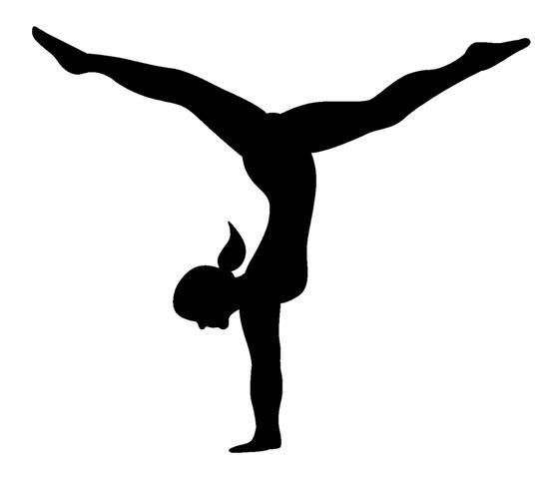
Jennie’s Chesapeake Gymnastics Club, LLC.
871 Keith Lane Unit 2
Owings, Maryland 20736
410-286-2646

Acknowledgement of Risk and Waiver of Liability and Permission to Treat

I (We) ______________________________________ hereby give permission for my/our
Child _____________________________________ to participate in classes/events conducted at Jennie’s Chesapeake Gymnastics Club, LLC. (JCGC).

I (We) ______________________________________ have read the welcome letter and have reviewed it with my child and agree to adhere to the terms and conditions.

I (We) ______________________________________ agree to support and abide by the policies and rules posted in the welcome letter or handbook for team gymnasts.

I (We) ______________________________________ understand that it is my responsibility to carry my own accident and medical insurance. In the event of an injury or accident, I (We) _______________________________ authorize customary medical treatment if it becomes necessary and transportation and emergency medical services if warranted. The enrolled child is capable of participating in the sport of gymnastics and has had a physical within the last (12) twelve months. Any activity involving motion, tumbling, height, swinging, etc… involves the possibilities of serious, permanent or even fatal injury.

I (We) _________________________________________ understand the risks of participating in the sport of gymnastics and therefore, in consideration for allowing my child to use JCGC’s equipment and facilities, I (We) _____________________________________ hereby forever release JCGC, it’s owners, officers, employees, teachers and coaches for all liability for any and all damage and injuries suffered by my child while under the instructions, supervision of control of JCGC, it’s owners, officers, employees, teachers, coaches.

This acknowledgement of risk and waiver of liability, having been read thoroughly and understood completely, is signed voluntarily as to its content and intent.

________________________________________________________________________________________
Date Signature of Mother or Legal Guardian

________________________________________________________________________________________
Date Signature of Father or Legal Guardian

________________________________________________________________________________________
Name of Gymnast(s)

